ADVANCED SQL:

Exercise 1 : Ranking & Window Functions :
Row Num():
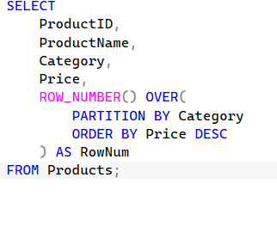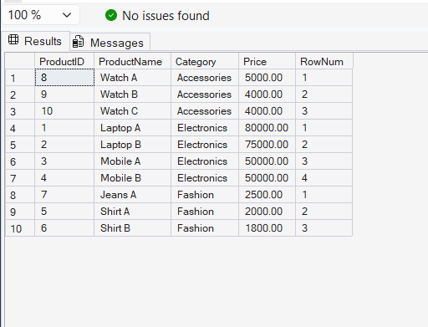
Rank Num():
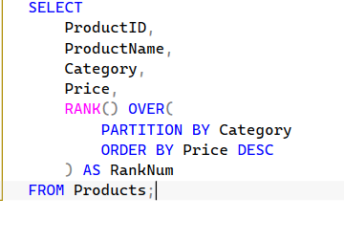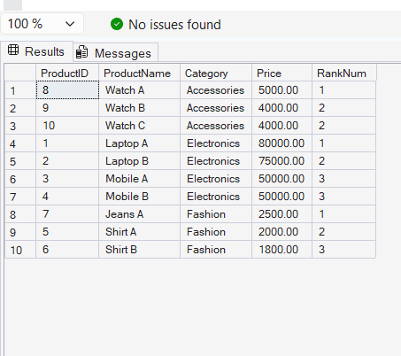

DenseNum():

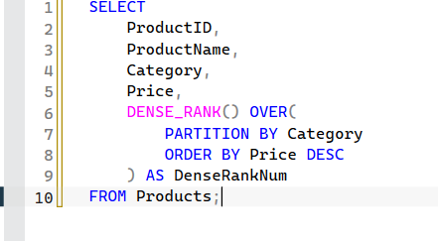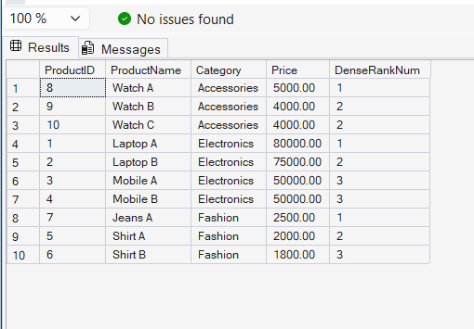
ROW_NUMBER():
Assigns a unique sequential number to each row within a partition.
RANK():
Assigns the same rank to tied values and skips subsequent ranks.
DENSE_RANK():
Assigns the same rank to tied values but does not skip ranks.
PARTITION BY:
Divides rows into groups before applying ranking functions.
OVER():
Defines the window or set of rows on which the function operates

